Skillet Name –PANOS OSPF Configuration

# 

# 

# Brief Description

This skillet provides a way to configure most of the OSPF parameters configurations.

# How to use

* Login into Panhandler, and import Skillets

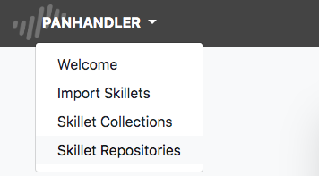

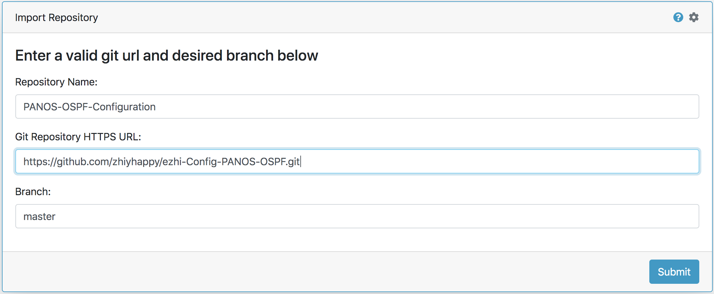

* Get into Skillet Collections and then select skillet: ***ezhi-PANOS-OSPF***, click Go, then you will get 1workflow and 6 separate steps shown on the page.

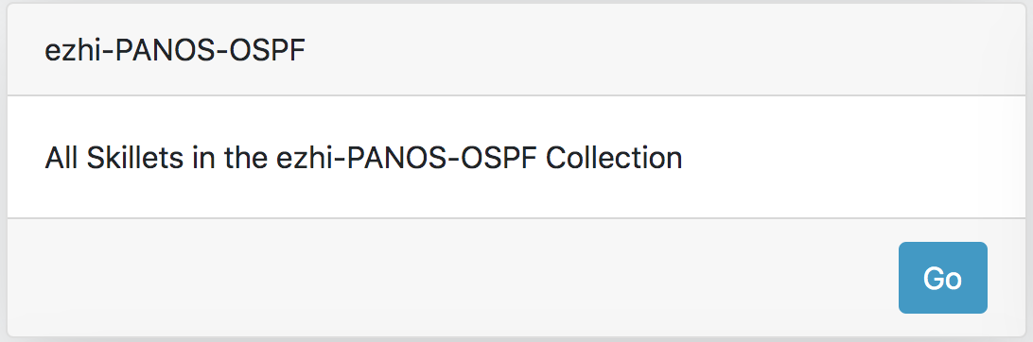

* Select ***ezhi-PANOS-OSPF***, click Go, then input the parameters for OSPF.

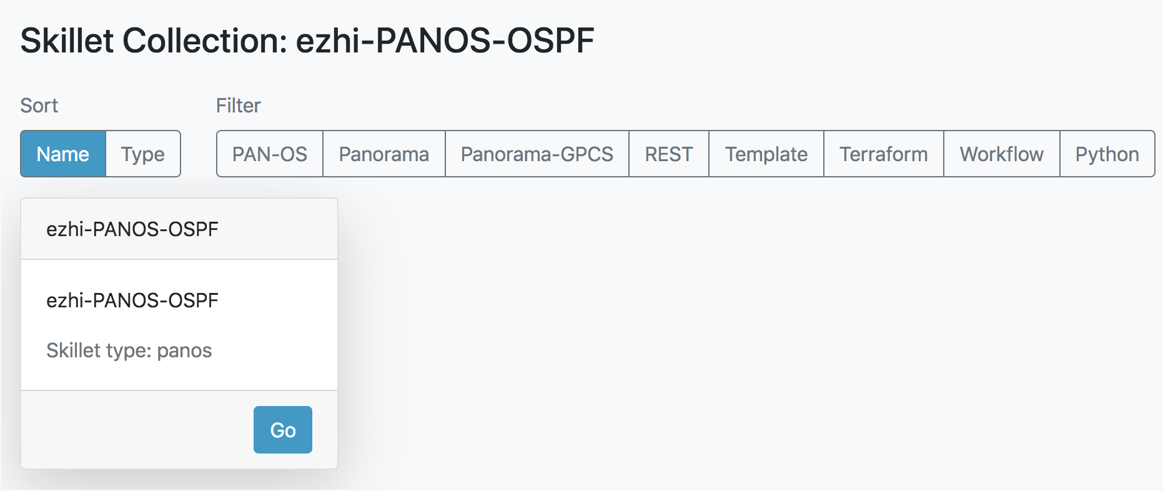

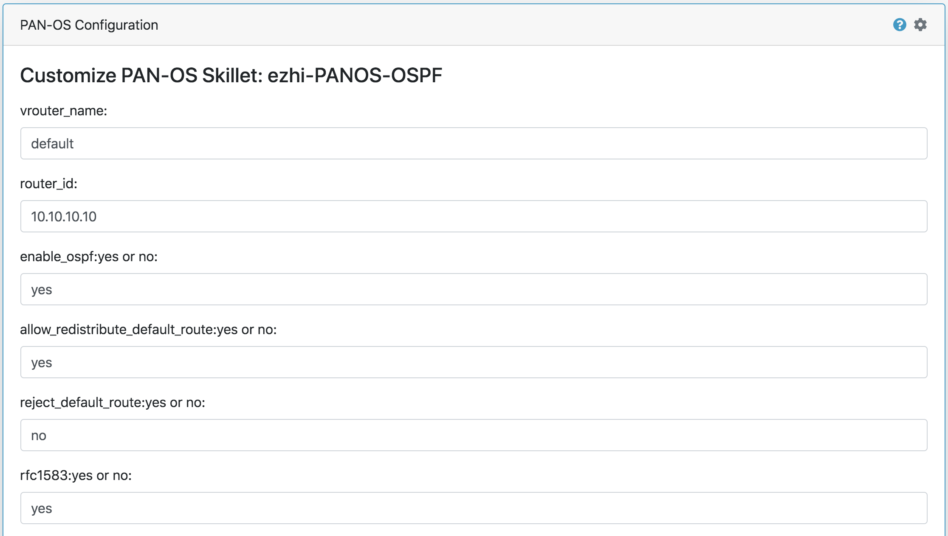

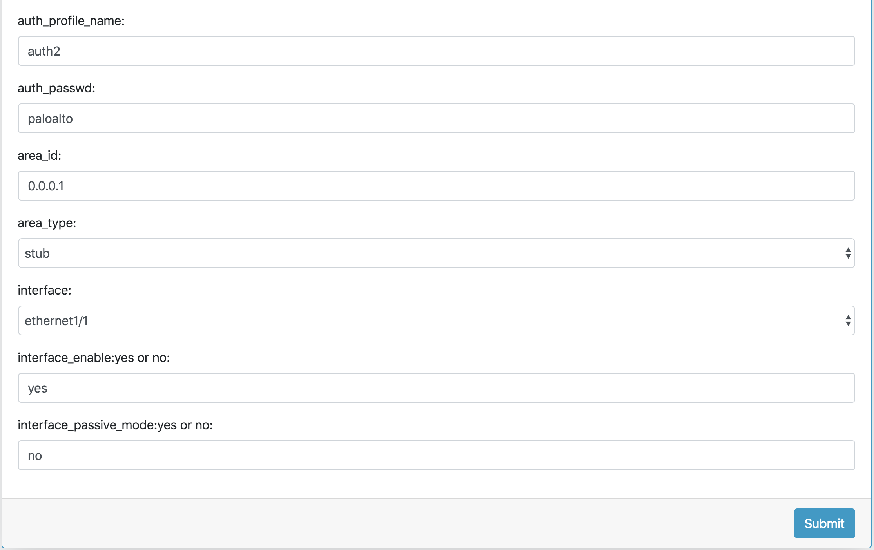

* The configurable OSPF parameters include:

|  |  |
| --- | --- |
| Parameters | Input or select |
| vrouter_name | input virtual router name, e.g. default |
| router_id | input virtual router id, e.g. 10.10.10.10 |
| enable_ospf | input yes or no |
| allow_redistribute_default_route | input yes or no |
| reject_default_route | input yes or no |
| rfc1583 | input yes or no |
| auth_profile_name | input text name, e.g. auth2 |
| auth_passwd | input authtication password |
| area_id | input id, e.g. 0.0.0.1 |
| area_type | select from drop down list, normal/nssa/stub |
| interface | select from drop down list |
| interface_enable | input yes or no |
| interface_passive_mode | input yes or no |

* After submitting, you need to input the PAN-OS IP, PAN-OS Username, PAN-OS Password, check the Perform Commit and Perform Backup as you want, then click Submit to finish the configuration.

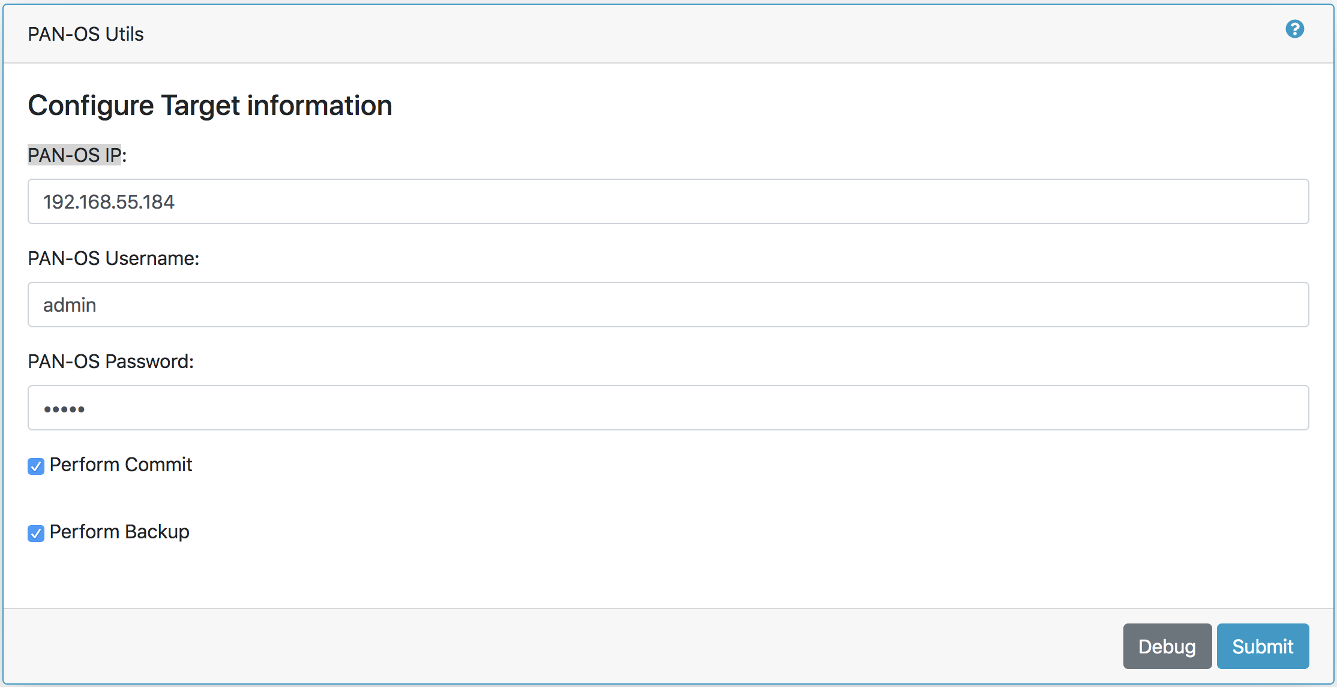

* You may repeat the previous to add more areas and interfaces into OSPF configuration .

# Github Repository

* https://github.com/zhiyhappy/ezhi-Config-PANOS-OSPF.git

# Requirements

* Panhandler
* PAN-OS 8.1 or greater